ENFLOW OPERATIONS SYSTEM – PROJECT SUMMARY (FOR CHATGPT)

Background
I work for Enflow Sanitary, a manufacturer of PTMT connection pipes.
We are building an Excel/Google Sheets based Operating System (not ERP) that will be used daily by the factory.
The goal is to build a lightweight ERP inside Google Sheets that can comfortably run the business until approximately ₹15–20 crore turnover.
Everything should be extremely simple because the factory staff are not advanced Excel users.

Company Operations
Current setup:
- 9 Assembly Machines
- 9 Labour
- Monthly salary
- Daily productivity tracking
The production process is:
- Put cap on pipe
- Insert nut
- Assembly using machine
- Add washer
- Put sticker on cover
- Insert pipe into cover
- Seal cover
- Bundle 10 pcs
- Put bundle in polybag
- Stitch polybag

Product Variants
Only four variants exist.
- 13 mm Round Nut
- 13 mm Hex Nut
- 13.5 mm Round Nut
- 13.5 mm Hex Nut

Pipe Lengths
- 18 in
- 24 in
- 30 in
- 36 in
- 48 in
- 1 m
- 1.5 m
- 2 m
- 3 m

Labour Productivity
Two working methods.

Full Process
Assembly

Packing

Sticker

Cover

Sealing

Bundling
Target
350 pipes/day
Daily rate
₹350

Assembly Only
Target
700 pipes/day
Daily rate
₹350

Current working process for references
1.Customer list
2.Vender list
3.courier entries
4.input order list process
5.billing process
6.Raw material Reordering process

Factory Structure
Owner
↓
Taha (Manager)
↓
Shivakumar (Operations Coordinator)
↓
Labour

Responsibilities

Owner
Dashboard only
Decision making
Major approvals

Taha
Customer orders
Production priority
Dispatch approval
QC approval
Customer communication
Order planning

Shivakumar
Attendance
Daily production
QC entries
Inventory transactions
Dispatch preparation
Daily reporting

Current Excel Philosophy
One Excel workbook
Upload to Google Drive
Open in Google Sheets
Everything interconnected
Very few manual entries
Everything else automatic

Version 3 Structure
Workbook contains:
- START HERE
- Dashboard
- Order Header
- Order Details
- Daily Production
- Attendance
- QC & Wastage
- Inventory Transactions
- Dispatch
- Master Data
- Settings

IMPORTANT CHANGE (Version 3)
Originally there was only one Order Planning sheet.
That was changed.
Now there are TWO order sheets.

Order Header
One row per customer order.
Example
Order No
ORD-001
Customer
Waterflow
Dispatch Date
15 Aug
Priority
High
Status
Open

Order Details
One order can have unlimited rows.
Example
Order ORD-001
Line 1
18"
13 mm Round
500 pcs
Line 2
24"
13 mm Round
5000 pcs
Line 3
1 m
13 mm Hex
200 pcs
Line 4
36"
13.5 mm Round
1000 pcs
Everything belongs to the same Order Number.
Production and dispatch happen line-wise.

Colour Coding
Extremely important.
Yellow cells
↓
User enters data.
White cells
↓
Formula.
Never edit.
Headers
↓
Blue.
Dashboard
↓
Read only.

Current Dashboard
Shows
Orders pending
Orders due today
Today's production
Today's dispatch
Labour present
Rework
Scrap
Daily productivity
Inventory alerts

Inventory Philosophy
Transaction based.
Never manually edit stock.
Transactions:
Purchase
Issue to Order
Return
Scrap
Adjustment
Running stock calculated automatically.

QC
Current defect list
Flash in parts
Wrong pipe length
Wrong ID
Wrong OD
Cap breaking
Loose assembly
Missing washer
Wrong label
Wrong cover
Improper sealing
Wrong bundle quantity
Damaged pipe
Other

Labour Attendance
Daily manual Entries in excel sheet
Attendance daily.
Salary monthly.
Performance daily.
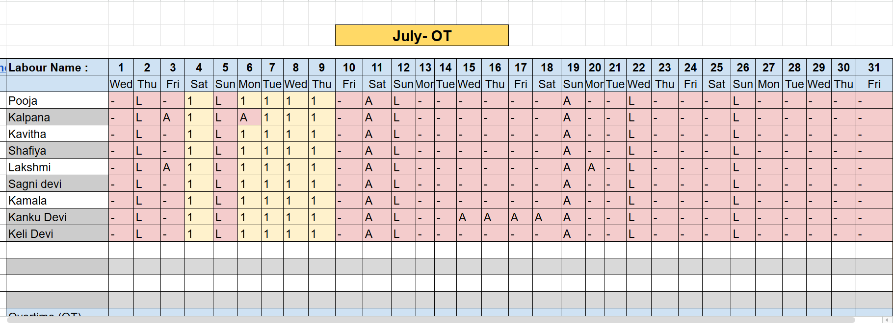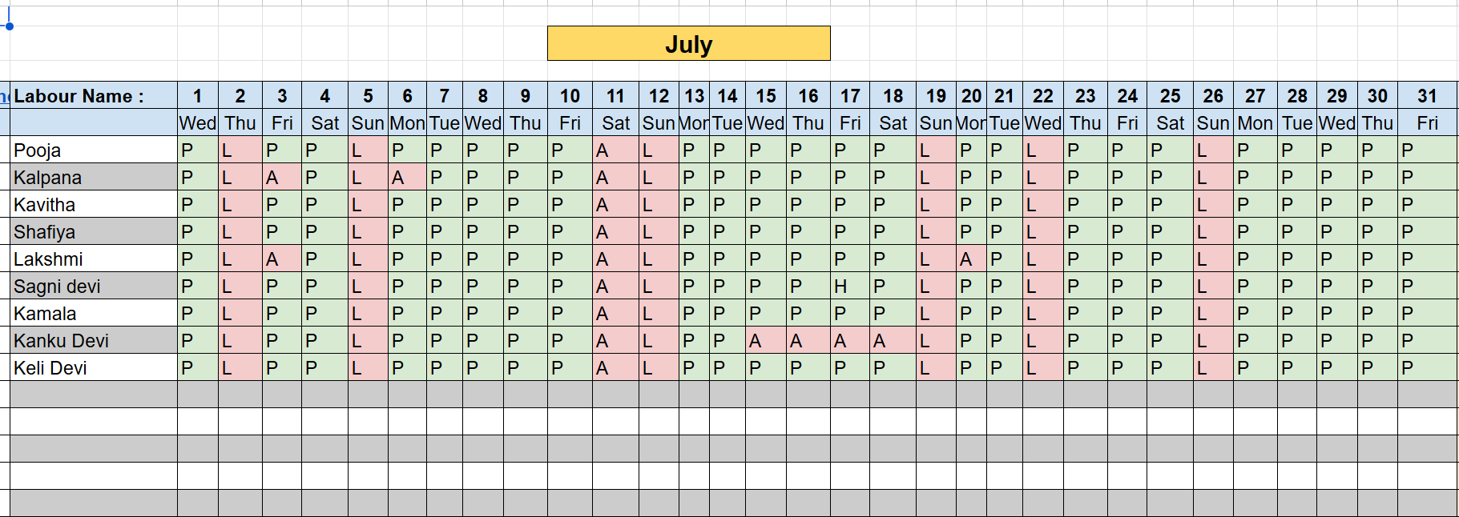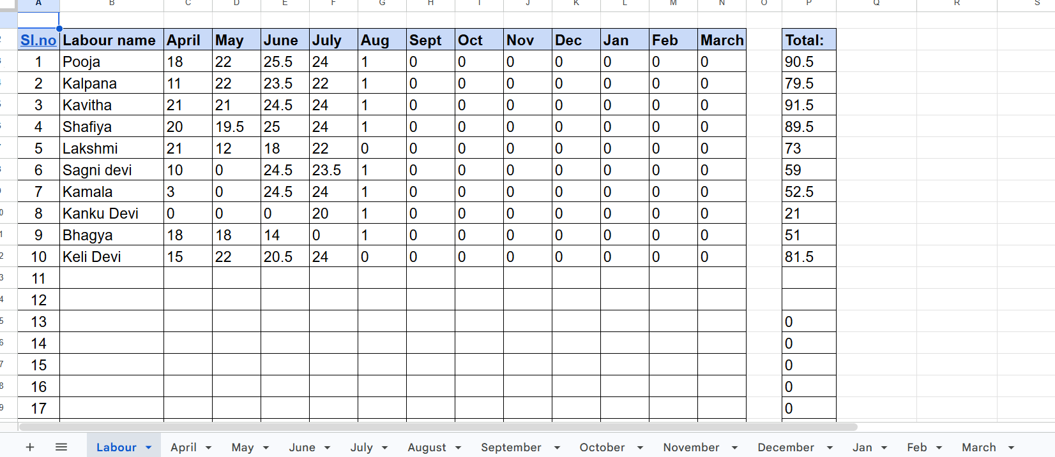

Daily Production Philosophy
Everything revolves around Order Number.
Production entries contain
Date
Order
Variant
Length
Labour
Machine
Target
Actual
Good Qty
Rework
Scrap
Daily earning

Dispatch
Dispatch is only complete after
Packing verified
Label verified
Quantity verified
Approved by Taha

Current Weaknesses (Need Version 4)
These are the next improvements.

1.
Production entry should be easier.
Currently operator selects:
Order
Variant
Length
Need automatic filtering.

2.
Inventory should automatically deduct based on BOM.
Not yet implemented.

3.
Dashboard needs charts.
Labour ranking
Machine utilization
Order ageing
Dispatch trend
Inventory trend

4.
Customer Order Form
Need a printable customer order sheet.

5.
Daily Work Sheet
Need printable paper for Shivakumar every morning.
Shows
Today's orders
Priority
Assigned labour
Target

6.
Packing List Generator
Automatically generate packing list from dispatch.

7.
Invoice Readiness
Need automatic "Ready for Invoice" status.

8.
Reorder Alerts
Need dashboard cards.
Caps
Washers
Labels
Covers
Pipes
Nut sets

9.
Better Google Sheets Experience
Need dropdowns.
Conditional formatting.
Protected formula cells.
Mobile friendly.

10.
Ultimate Goal
Build a Google Sheets system that behaves like a lightweight ERP, where:
- The owner only checks the Dashboard.
- Taha manages customer orders and approvals.
- Shivakumar updates only the yellow input cells.
- Everything else (production, pending orders, inventory, labour productivity, QC, dispatch, and KPIs) updates automatically.
The priority for the next version is usability, not adding more features. Every screen should require the minimum possible data entry while giving maximum operational visibility.

